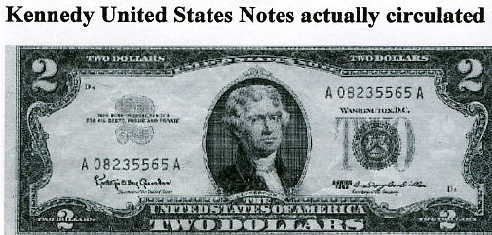
JFK'S REAL AMERICAN DOLLARS
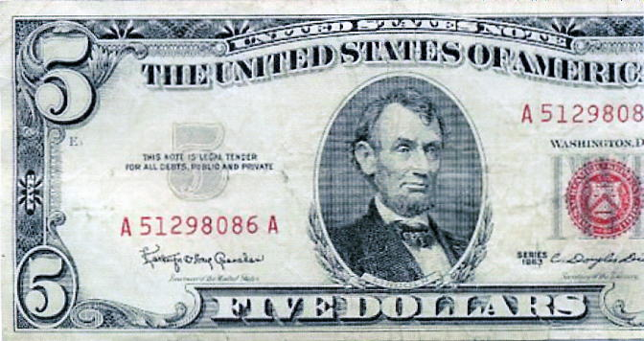
The Last Real American Dollar
by Bill Downey, Goldtrends, Dec 15, 2009
Every now and then there are extraordinary events that occur that end up shaping the world for many years to come. The Lincoln and JFK assassinations come to mind. More recently, 39 years ago (Dec 8 1980), John Lennon was gunned down in front of his own house. In many ways, the generation that grew up with him, grew up that night. As he eloquently put in his post Beatles album, "The Dream is Over." For that generation it was.
And what of JFK? That day in Dallas was in many ways where the changing of the guard that Kennedy inherited was circumvented. Indeed, one can only ponder had the "old guard" not regained control of the throne what the potential for this day and age might have been. Now a lot has been written about JFK, good and bad, true and false, and the realm of conspiracy has been pondered by most that have done any study of the events.
But that is not what this is about. This is about the last REAL AMERICAN MONEY. When one looks at real money, gold coins per se, it is hard not to notice the references to freedom and liberty. That is because "REAL MONEY" is freedom............. and liberty. It always has been, and it always will be. The truth be known, the modern route to slavery is through DEBT.
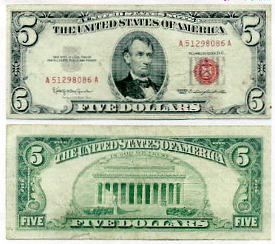
Take a good look at this five dollar bill above. There is one thing that is different than any other bill you have seen in circulation. That difference when viewed in the lens of today has profound implications. Can you spot what the difference is? (It is not the red seal). Take a few moments before your read the answer below. Take a good look. What is different and what is the implication? What many people don't know about JFK is that he was the last American President to print money that was NOT backed by the Federal Reserve. Let me repeat the last portion of the sentence. ..........MONEY THAT WAS NOT BACKED OR PRINTED BY THE FEDERAL RESERVE!!! What you are looking at is a "UNITED STATES NOTE" - So ordered by John F Kennedy, president of the United States. Constitutionally, JFK had this money printed. Only Government has the legal authority to coin legal tender money.
Look at the very top of the front of the [JFK five-dollar] bill above; at the very top middle. See how it says "UNITED STATES NOTE" instead of "FEDERAL RESERVE NOTE"? [see Federal Reserve one dollar bill below~jj]:
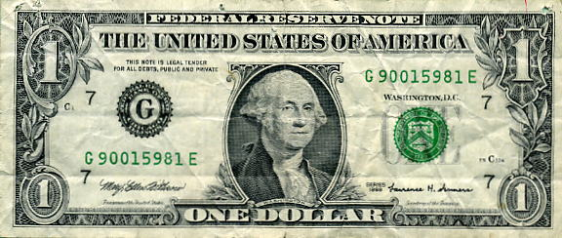
The ramifications are too much for me to contemplate, but the bottom line is that JFK was issuing money (REMEMBER THE 2 DOLLAR SILVER CERTIFICATE BILL) that was either backed up by silver or in this case above, was not "BORROWED" from the Federal Reserve. Now if the Feds had gold to back up all that they would print it would be a different story. But they do not.
It is often said that if you want to get on the trail of the truth in history, follow the money. While we will never know the entire details of the JFK assassination, I find it interesting that these bills were QUICKLY CANCELLED after his assassination and not issued? Why?
One way or another, the Federal Reserve, the ones who are up to their necks in sharing the responsibility for the current collapse of the USA, regained "control" of the money supply with the death of JFK. That is a very big historical convenience wouldn't you say?
When push came to shove in 1971, Richard Nixon closed the gold window forever. This became the point of LIFT OFF (INFLATION) FOR THE ENTIRE GLOBAL ECONOMY we know of today. In fact, the first place Nixon headed after the gold window closed was to CHINA................ TO OPEN THE DOOR OF TRADE. It really was about minimizing inflation by transferring the manufacture of US goods at an extremely low labor cost point of manufacture. The rest is history. The USA's manufacturing base (the production of things) was basically transferred to China....
The Last Real American Dollar, by Bill Downey, Goldtrends, Dec 15, 2009

USA dollar in jeopardy of losing it's value, Market Oracle, Feb 1, 2010
...China's peg to the dollar: So far China is enjoying low yuan rate giving its exports competitive advantage against those of the countries with appreciating currencies triggered by the weakness of the dollar. As the result China is actually "stealing" jobs from many countries since with appreciating currencies their companies are not able to compete with Chinese producers. In relation to the United States this means that the country should not count on sooner recovery. China's peg to the dollar makes imports into the U.S. cheaper. This supports high level of unemployment in America. Unemployment prevents the growth of GDP and reduces revenues....
Kissinger celebrates China/USA relationship (friendly with last four Red China leaders; advisor to eight USA presidents) & Red Chinese celebrate at NY Stock Exchange (Obama praises Chinese economic system). ChinaDaily, AP, Jan 10, 2009. Go to CHINESE TAKE-OVER
China collapsing US dollar. Financial Post, Nov 8, 2007 (...The euro surged to a record high against the U.S. dollar yesterday, touching $1.4731, a 65 per cent gain since the end of 2001. Analysts say the euro has become the main threat to the U.S. dollar's dominance; while political leaders worry its rising value is hurting European exports. The euro made its debut as an accounting currency in 1999 and was put into wide circulation as physical money in 2002. It is the currency of the 13-country euro zone, which includes Austria, Belgium, France, Germany, Greece, Ireland, Italy, Luxembourg, the Netherlands, Portugal, Slovenia, Spain and Finland. In December 2006, the combined value of all euro notes in circulation exceeded that of the U.S. dollar for the first time. French President Nicolas Sarkozy said yesterday currency "disarray" – including a weak U.S. dollar and overvalued Chinese yuan – could lead to "economic war."...)
KENNEDY EXECUTIVE ORDER 11110 (On June 4, 1963, President John F. Kennedy signed Executive Order No. 11110 that returned to the U.S. government the power to issue currency, without going through the Federal Reserve (US Central Bank). Mr. Kennedy's order gave the Treasury the power "to issue silver certificates against any silver bullion, silver, or standard silver dollars in the Treasury." This meant that for every ounce of silver in the U.S. Treasury's vault, the government could introduce new money into circulation. As a result, more than $4 billion in United States Notes were brought into circulation in $2 and $5 denominations. $10 and $20 United States Notes were never circulated but were being printed by the Treasury Department when Kennedy was assassinated. With the stroke of a pen, President Kennedy was on his way to putting the Federal Reserve Bank out of business. If enough of these silver certificats were to come into circulation they would have eliminated the demand for Federal Reserve notes. This is because the silver certificates are backed by silver and the Federal Reserve notes are not backed by anything. After Mr. Kennedy was assassinated just five months later, no more silver certificates were issued. The Executive Order was never repealed by any U.S. President through an Executive Order and is still valid. Why then has no president utilized it? Virtually all of the nearly $6 trillion in debt has been created since 1963, and if a U.S. president had utilized Executive Order 11110 the debt would be nowhere near the current level.
Kennedy Executive Order 11110, Hub Pages
On June 4, 1963, President John F. Kennedy signed Executive Order No. 11110 that returned to the U.S. government the power to issue currency, without going through the Federal Reserve (US Central Bank). Mr. Kennedy's order gave the Treasury the power "to issue silver certificates against any silver bullion, silver, or standard silver dollars in the Treasury." This meant that for every ounce of silver in the U.S. Treasury's vault, the government could introduce new money into circulation. As a result, more than $4 billion in United States Notes were brought into circulation in $2 and $5 denominations. $10 and $20 United States Notes were never circulated but were being printed by the Treasury Department when Kennedy was assassinated.
With the stroke of a pen, President Kennedy was on his way to putting the Federal Reserve Bank out of business. If enough of these silver certificats were to come into circulation they would have eliminated the demand for Federal Reserve notes. This is because the silver certificates are backed by silver and the Federal Reserve notes are not backed by anything. After Mr. Kennedy was assassinated just five months later, no more silver certificates were issued. The Executive Order was never repealed by any U.S. President through an Executive Order and is still valid. Why then has no president utilized it? Virtually all of the nearly $6 trillion in debt has been created since 1963, and if a U.S. president had utilized Executive Order 11110 the debt would be nowhere near the current level.
John F. Kennedy, Executive Order 11110. The American Presidency Project
"By virtue of the authority vested in me by section 301 of title 3 of the United States Code, it is ordered as follows: The authority vested in the President by paragraph (b) of section 43 of the Act of May 12, 1933, as amended (31 U.S.C. 821 (b)), to issue silver certificates against any silver bullion, silver, or standard silver dollars in the Treasury not then held for redemption of any outstanding silver certificates, to prescribe the denominations of such silver certificates, and to coin standard silver dollars and subsidiary silver currency for their redemption"...JOHN F. KENNEDY, THE WHITE HOUSE, June 4, 1963
Reader Brian says the link to executive order 11110 doesn't connect from the Home Page of the JFK library anymore
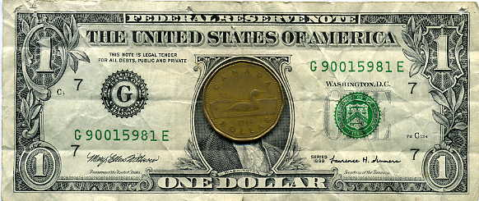AMERICAN DOLLAR IN LOONIE BIN
Reader Quint points out that the Executive Order 11110 link isn't working
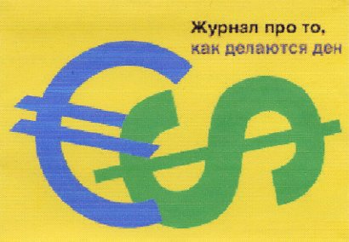JFK DEFENDED DOLLAR, speech to International Monetary Fund, Sep 30, 1963 ("The security of the dollar involves the security of us all...We are determined to do whatever must be done in the interest of this country and, indeed, in the interest of all to protect the dollar as a convertible currency at its current fixed rate....")
JFK Library Executive Order 11110 (Relating to the performance of certain functions affecting the Dapartment of the Treasury...)
GREENSPAN FROM JEKYLL ISLAND
CREATURE FROM JEKYLL ISLAND (excerpt from book)
LINCOLN & KENNEDY MADE MONEY
LINCOLN'S ASSASSINTATION & JFK'S ASSASSINATION & RETHINKING JOHN LENNON'S ASSASSINATION
Jackie Jura
~ an independent researcher monitoring local, national and international events ~
email: orwelltoday@gmail.com
HOME PAGE
website: www.orwelltoday.com

