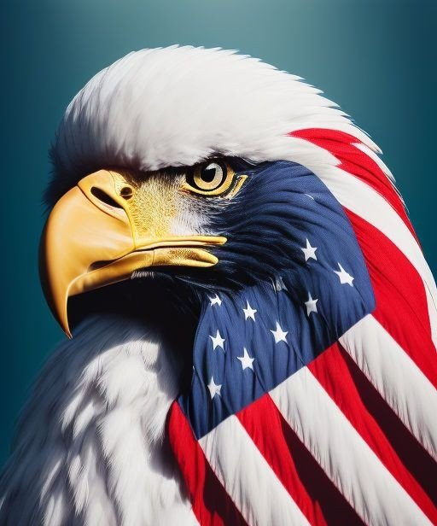
Credit to:
@Prolotario1

Status Of The Republic: Liberation & Justice When you are in bankruptcy as a corporate entity you do not have any contract rights.
• Buckingham Palace
• The Vatican
• Washington DC
• City of London
• State of Israel
All these corporate bodies filed for Chapter 11 bankruptcy. The Act of England 1871 was repealed. The Secondary Judiciary Act 1869 is no longer active. The International Emergency Economic Powers Act (IEEPA). The IEEPA gives the President the power to impose economic sanctions on foreign countries and individuals in response to a national emergency.
EO (13818) EO (13848) EO (13959)
These executive orders allowed the US to seize the assets of corporate entities and persons. For human rights abuse and election interference. Stocks Shares Trade Bank Account Business Home Investment Company Etc. All assets.
Did you know Evergreen Inc. is a CIA owned company?
Who uses that for human trafficking? Hillary Clinton.
Guess what is contracted with Evergreen? ■ The Vatican ■ The US ■ City Of Rome ■ UN Corp ■ The Holy See ■ UK Inc (This Is Key) All subcontracted. Each step of subcontracting process, the accountability of each subcontractor diminishes relative to the actual contract. And what have you got? You have Evergreen Inc. owned and operated by Evergreen, LLC, which is owned and operated by Evergreen, PLC. 4500 employees, no obligation to file flight plans (Hint-Hint) and you have a totally unaccountable self-interested for profit corporation abusing the powers of "government".
All of this as a result of the EOs are null/void.
-Do you remember when Jan Halper confirmed that tons of gold were removed from the Vatican?
-Do you remember when the 1871 Corp Act was dissolved on May 4 2020?
-Do you remember then months after that the New Republic with the original Constitution was invoked on July 4, 2020 when D. Trump visited Mount Rushmore?
-Do you remember the Balfour Declaration? Palestine was under UK rule on 2 November 1917 when foreign minister Arthur Balfour wrote to Lord Rothschild, a leader of the British Jewish community. Palestinians made up 90 per cent of the population in 1917. They blame the declaration for encouraging Zionists and ultimately handing their land to the Jewish homeland - the future lsrael- by 1947. Remember the state of Israel was created by Khazarians. As result of the EOs they Israel became bankrupt. And what happens as a result? War. Which is going on between Israel & Palestine correct? For what? Land acquisition. Why? Because the Khazarians were kicked out of Ukraine by V. Putin. The assets of ex-president of Ukraine, Petro Poroshenk were frozen. It cut off a lifeline of drug, arms and human trafficking money essential to the survival of the Washington. Do you see how this connects to the current conflict? The Khazarian Mafia Money Laundering base is in Ukraine. The last country that they the Khazarian Mafia has is Israel. Remember who established Israel? The Rothschilds.
Donald Trump is the first leader to have broken that control and removed them from power in the USA by taking control of the FED.
This is why the attacks on him are so vicious and relentless, and they come from all sides. Political, Media, Military, Sports, etc. Since the USA was always the Rothschild’s strongest territory – to control the rest of the world, with its powerful army, these global criminals have pulled out all the stops to overturn a duly elected president. They have activated and unleashed all their assets to achieve this.
Remember the Q-Drop "All Assets Deployed"? D. Trump is the only world leader who has defeated the Rothshilds by hijacking their central bank in the USA.
This happened quietly during March 2020, and without any media coverage, because the media is owned by the same Rothschild banking empire. The Fed-Reserve is now under the US Treasury. Which is why the printing press no longer pump out endless fiat USD. Which was used to suppress the Middle East through the petro dollar. Iraq by January 1st 2024 will no longer use the USD in everyday commerce unless you are a traveler who needs it for international flights.
I told you all the 1st domino has not fallen yet publicly.
A month ago Mike Johnson (Now Soth) stated that Article 1 Sec 2 of the US Constitution that the sole power of Impeachment belongs to the Republican House Of Representatives. And Article 2 SEC. 4 states "The President Shall Be Removed From Office. On impeachment for and conviction of the following.
• Treason
• Bribery
• Money Laundering
• Misdemeanor Or other high crimes.
Americans now know from investigations launched by the House Committee that through domestic and international business dealings ran a illegally that the J. Biden administration is now liable for "Crimes Against Humanity".
Do you all see how they were setting the scene for the general public?
Who have no clue of the DOD Law of War Manual or the COG/JAG. Or even the Brunson Case. Because as I said the other day everything that is happening publicly is a result of what already happened privately. Do you all find it peculiar that after Clarence Thomas accepted the 11th Circuit Emergency Writ for the 2020/2022 Election Fraud Case 24 hrs before the new SOTH was chosen? Timing. We are in a transition period away from the 1871 Corp Act.
Removing Joe Biden is basically removing the US from Khazarian/Rothschild control of our country. The DOD-(Department of Defense) has already established a presidential transitional order that became effective on February 3rd 2023.
People seem to have forgotten about the GGMF-(Global Gold Mutual Fund) who are creating a gold standard for the Philippines with invitations for other countries to come on board by January the 20th, 2024. Who is supposed to have an international currency backed by gold by January 1st? Iraq.
Who are the BRICS waiting for to reinstate their currency on the Forex Market? Iraq.
America has billions in IQD. Which once the IQD rate is released on the international trade markets will liquidate countries around the world who will overnight have trillions worth of IQD once it is converted into their domestic national currency.
Which will help build their new republic. For those who have been asking why the IQD is so important. This will Usher in "The Golden Age" for next century and beyond. Which is why last week Kevin McCarthy mentioned for the 1st time publicly that we are under COG. The Military was founded first in our Nation. This means they are over every branch of government including the president.
The United States Supreme Court, first time in History, clarified this in the Military Justice Act of 2016. Though it didn’t pass until they went under COG in the 2017 National Defense Authorization Act.
The Military Justice Act clarifies 3 things:
1. Military Law supersedes Civilian.
2. President and Commander-in-Chief are separate.
3. Article II of the Constitution, Commander-in-Chief, is separate from Article III, Federal Government. Our Founders established a Military 1st, the Army, Navy, and Marines long before Declaration of Independence, Articles of Confederation, Constitution, and the Bill of Rights.
We have been in a "Peaceful Transition Of Power" since 2020. This is what Donald Trump meant when he stated that he put the government on pause. All of this is under transition now with gold no longer being suppressed and over 200 countries dumping the USD. We are now ready for the initiation of "The New Republic".
Do you remember when The razor-wire-lined fence that had drawn a circle around the Capitol, Supreme Court and federal office buildings?
This was the US Military deeming it foreign occupied territory sense it was under the District of Columbia.
That Municipal Government is a plenary oligarchy run by the members of Congress and it conveniently fails to say which Congress. There are four (4) Congresses possible.
1st. There's the Continental Congress which is a Congress of our States attended by State Deputies.
2nd. There's the Congress of the Federal Republic, which is supposed to be operated by our long- defunct Confederation of States of States.
3rd. There's the U.S.Congress, composed of "REPRESENTATIVES" from the FOREIGN-BORN Territorial State of State organizations that have been illegally and immorally commandeering our actual American Government since the 1860's.
4th. There's the Municipal US CONGRESS, composed of franchise operators of the Municipal United States the aforementioned Municipal Plenary Oligarchy.
Since the Municipality of Washington, DC, is an "independent, international city state" squatting on our shores, and its government is a "plenary oligarchy" run by the members of some unidentified "Congress" we were left with a gang of international criminals operating pirate base on our East Coast. This is coming to an end. Because what is coming up on October 31st?
The expiration of the State of Israel. Remember if the Rothschilds control both the Federal Reserve & Israel and both are bankrupt where does that leave US Congressional Members who have dual citizenship? Powerless.
Do you think the new SOTH knows this? Absolutely.
Why do you think he announced that he is putting a bill together for Israel instead of a budget?
I told you the difference between two yesterday. The new government program will not be for the current status of Israeli government. The parliament has already resigned.
What's next?
• Stock Market Crash
• Joe Biden Impeachment
• Gold Standard Return
• Iraq IQD Exchange Rate
• The New Republic
• Liberation & Justice Mike Johnson & Donald Trump are basically the same person.
Remember when D. Trump stated last month that we can take our country back before the primaries? 25+ States already have bills prepared to return to the gold standard.
We have nothing to worry about. Because everything is officially in writing. You heard it from Kevin McCarthy. You heard it from Mike Johnson. You heard if from Jan Halper You heard it from Donald Trump You heard it from the military.
What more confirmation do you need?
Do you know how many banks are closing due to the fact that they are not Basel 3 Compliant? These are the only banks where people have difficulty accessing their funds. Thanks to the Dodd Frank Act it basically made it legal for banks to confiscate your money without any explanation as to why your money is missing hundreds to thousands of dollars. Which is why it is important to ask certain questions before you open any new account with any bank.
Are they Basel 3 Compliant?
Are they ISO-20022 Compliant?
Are they Protocol 20 Compliant?
Stay tuned for more.

